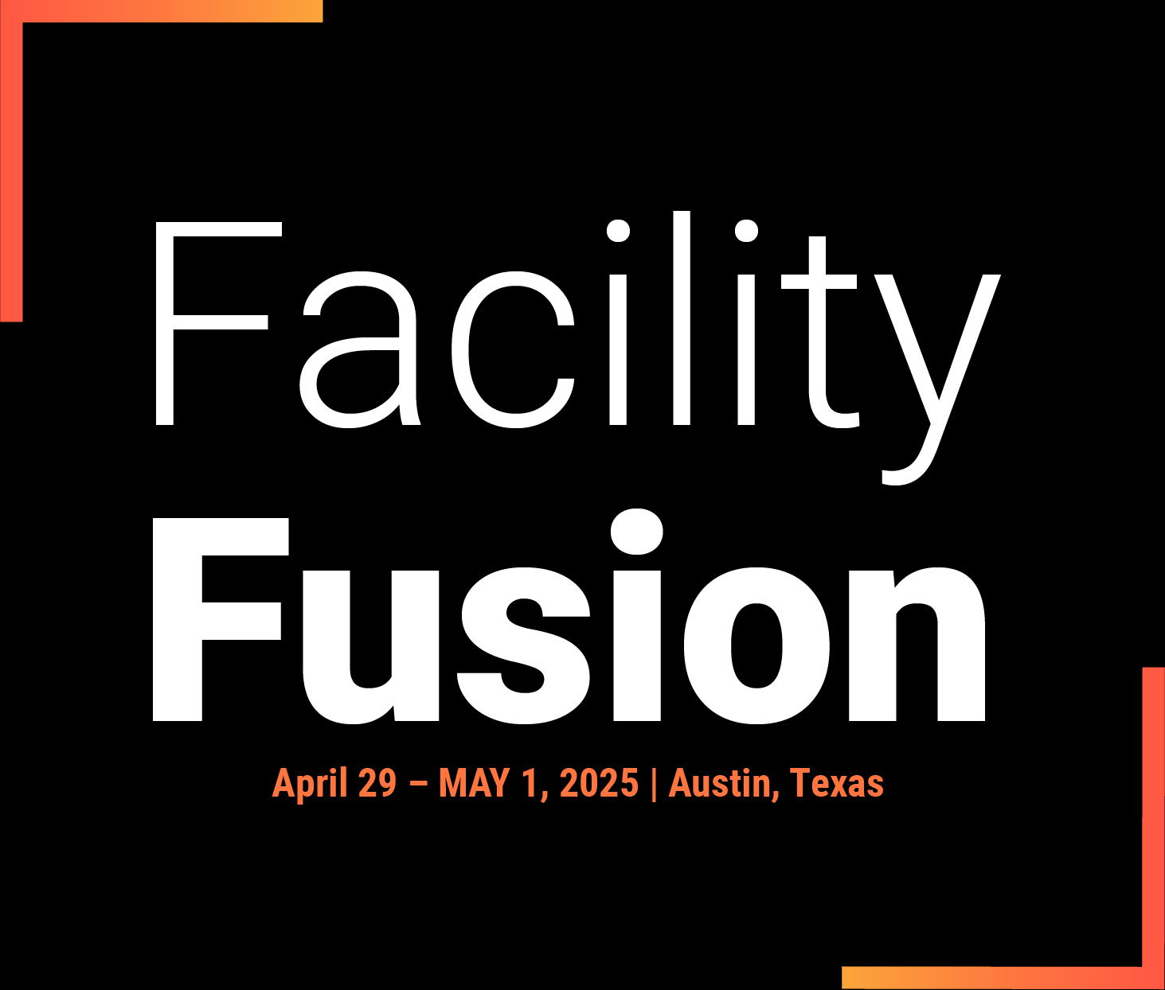
Hi [Colleague's name],
Ready to supercharge your facility management expertise? I'm heading to Facility Fusion 2025 in Austin, Texas from April 29-May 1, and I'd love for you to join me! This isn't just another conference – it's three days of cutting-edge insights, hands-on learning, and valuable connections with industry leaders.
Your fantastic work on [specific project/area of interest] has me convinced you'd get incredible value from the sessions on [relevant topic]. And let's be honest – who wouldn't want to mix professional development with some authentic Texas BBQ and live music in one of America's most vibrant cities?
I'm excited about the possibility of attending together and would be happy to walk you through the conference highlights. What do you say – ready to make this a team adventure?
Best regards, [Your name]
facilityfusion.ifma.org

